**LAB CYCLE 2**

**Submitted by,**

**NANDANA ANIL**

**MCA S1**

**ROLL NO: 107**

**LAB CYCLE 2 QUESTION 1:**

**AIM:** Create an HTML page to explain the use of various predefined functions in a string and math object in JavaScript.

**PROGRAM CODE:**

|  |  |
| --- | --- |
| CO2-1.html | <html>  <body>  <h2>JavaScript Strings</h2>  <p id="name"></p>  <p id="length"></p>  <p id="char"></p>  <p id="concat"></p>  <p id="index"></p>  <p id="search"></p>  <p id="matching"></p>  <p id="rep"></p>  <p id="sli"></p>  <p id="case"></p>  <font color="red">3 to the power of 4 is:</font>  <p id="math1"></p>  <font color="green">Maximum value is:</font>  <p id="math2"></p>  <font color="blue">Square root:</font>  <p id="math3"></p>  <script>  var x = "Nandana Anil.";  document.getElementById("name").innerHTML = x;  var txt = "ABCDEFGHIJKLMNOPQRSTUVWXYZ";  var sln = txt.length;  document.getElementById("length").innerHTML = sln;  var str = 'javascript string functions';  document.getElementById("char").innerHTML =str.charAt(8);  document.getElementById("concat").innerHTML =x.concat(str);  document.getElementById("index").innerHTML =x.indexOf('d');  document.getElementById("search").innerHTML =str.search("functions");  var st="Javatpoint";  document.getElementById("rep").innerHTML =st.replace("tpoint","Script");  document.getElementById("matching").innerHTML =st.match("Java");  document.getElementById("sli").innerHTML =st.slice(5,9);  document.getElementById("case").innerHTML =txt.toLowerCase();  document.getElementById('math1').innerHTML=Math.pow(3,4);  document.getElementById('math2').innerHTML=Math.max(22,34,12,15);  document.getElementById('math3').innerHTML=Math.sqrt(64);  </script>  </script>  </body>  </html> |

**RESULT:**

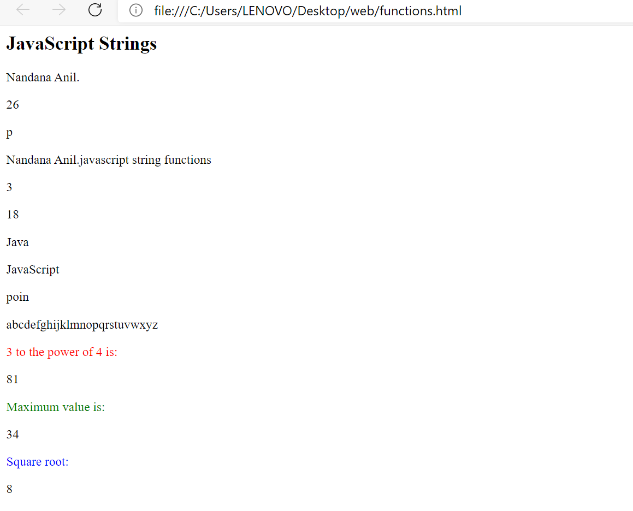

**LAB CYCLE 2 PROGRAM NO 2**

**AIM:** Calendar using JavaScript code by getting the year from the user.

**PROGRAM CODE:**

|  |  |
| --- | --- |
| **CO2-2.html** | <html>  <head>  <center>  <h1><b>Full Calender of Given year</b></h1>  </center>  <body bgcolor="lightblue">  <script language="javascript">  function day_title(day_name)  {  document.write("<td align=center width=35 bgcolor=grey><b>"+day_name+"</b></td>");  }  function fill_table(month,month_len)  {  day=1;  document.write("<table border=1 cellspacing=5 cellpadding=10%>");  document.write("<td colspan=7 align=center bgcolor=pink><b>"+month+" "+year+"</b><tr>");  day_title("Sun");  day_title("Mon");  day_title("Tue");  day_title("Wed");  day_title("Thu");  day_title("Fri");  day_title("Sat");  document.write("</tr><tr>");  for(var i=1; i<start_day;i++)  {  document.write("<td>");  }  for(var i=start_day; i<8;i++)  {  document.write("<td align=center bgcolor=white>"+day+"</td>");  day++;  }  document.write("<tr>");  while(day<=month_len)  {  for(var i=1; i<=7 && day<=month_len;i++)  {  document.write("<td align=center bgcolor=white>"+day+"</td>");  day++;  }  document.write("<tr>");  start_day=i;  }  document.write("</tr></table><br>");  }  year=prompt("enter 4 digit year ",2016);  today=new Date("January 1, "+year);  start_day=today.getDay()+1;  fill_table("January", 31);  if (year%4==0)  fill_table("February", 29);  else  fill_table("February", 28);  fill_table("March", 31);  fill_table("April", 30);  fill_table("May", 31);  fill_table("June", 30);  fill_table("July", 31);  fill_table("August", 31);  fill_table("September", 30);  fill_table("October", 31);  fill_table("November", 30);  fill_table("December", 31);  </script>  </head>  </html> |

**RESULT:**

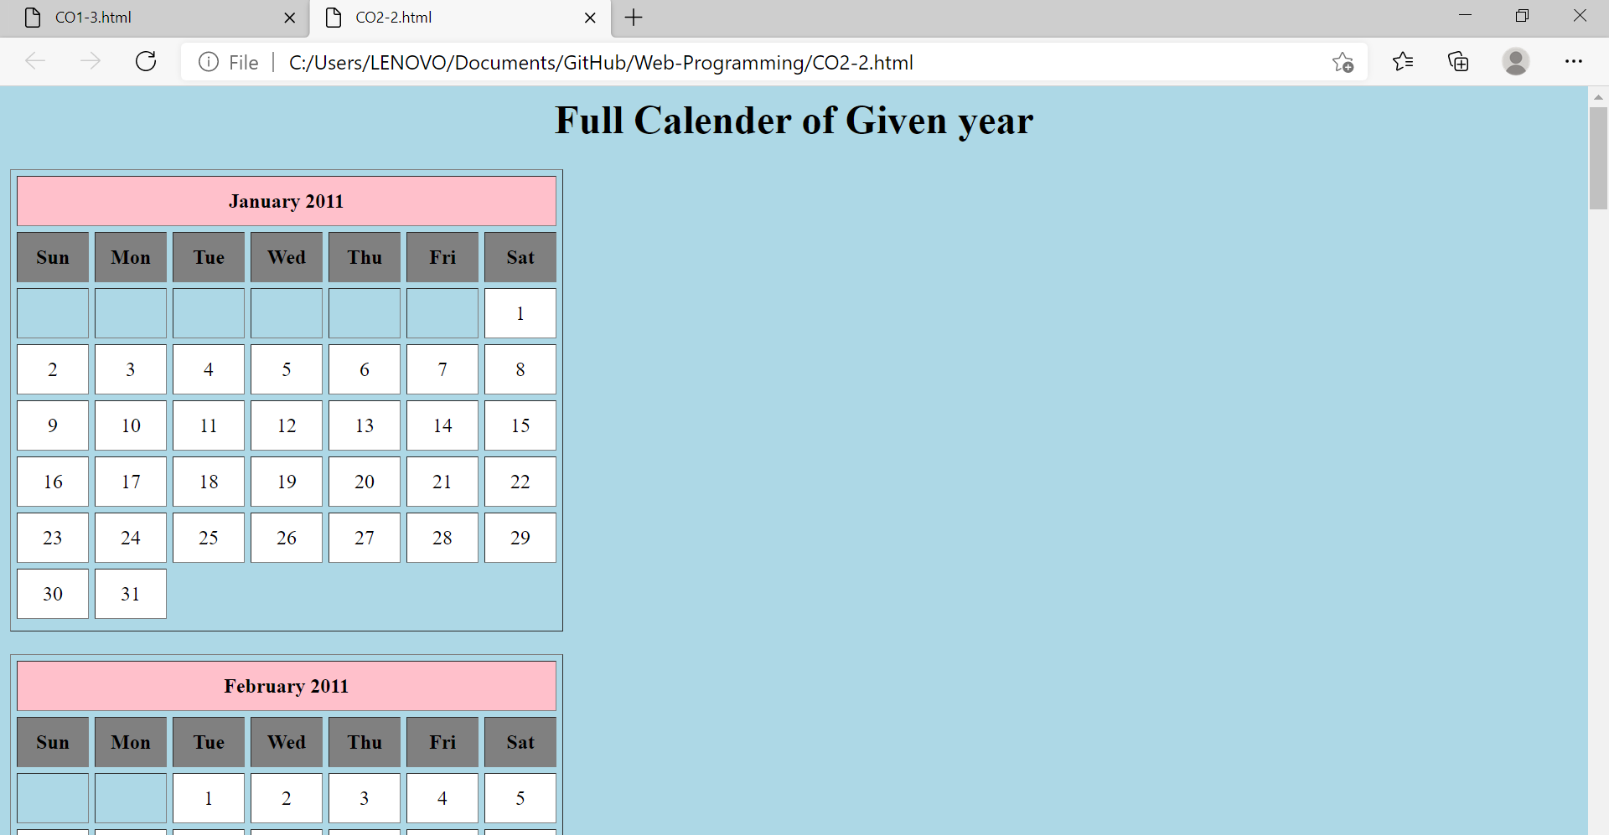

**LAB CYCLE 2 PROGRAM NO: 3**

**AIM:** Create a HTML registration form and to validate the form using JavaScript code.

**PROGRAM CODE:**

|  |  |
| --- | --- |
| CO2-3.html | <html>  <head>  <title>Name and Age  </title>  <script text="JavaScript">  function checkData()  {  var T_name,T_age,N_age,addr,phno,email,pwd;  T_name=(document.formvalid.txtName.value);  if(T_name=="")  {  alert("Please Enter a Valid Name!!!!!!!!!!!!!!");  return;  }  T_age=(document.formvalid.txtAge.value);  if(T_age=="")  {  alert("Please Enter Age!!!");  return;  }  if(isNaN(T_age))  {  alert("Please Enter a number as the Age!!!");  return;  }  N_age=Number(T_age);  if(N_age<15 ||N_age>20)  {  alert("The age must be between 15 and 20!!!");  return;  }  addr=(document.formvalid.txtArea.value);  if(addr=="")  {  alert("Please Enter a Valid address!!!!!!!!!!!!!!");  return;  }  phno=(document.formvalid.txtPhone.value);  if(phno=="")  {  alert("Please Enter a Phone Number!!!!!!!!!!!!!!");  return;  }  if(phno.length<10)  {  alert("Phone no must contain 10 digits!!!!!!!!!!!!!!");  return;  }  email=(document.formvalid.txtEmail.value);  if(email=="")  {  alert("Please Enter an email id!!!!!!!!!!!!!!");  return;  }  pwd=(document.formvalid.txtPwd.value);  if(pwd=="")  {  alert("Please Enter a password!!!!!!!!!!!!!!");  return;  }  }  </script>  </head>  <body>  <form name="formvalid">  <h1>REGISTRATION FORM</h1><br><br>  <font size="6">Name:  <input type="text" name="txtName"><br><br>  Age:  <input type="text" name="txtAge"><br><br>  Address:  <input type="text" name="txtArea"><br><br>  Phone No:  <input type="text" name="txtPhone"><br><br>  Email Id:  <input type="text" name="txtEmail"><br><br>  Password:  <input type="password" name="txtPwd"><br><br>  <input type="button" value="ENTER" onClick="checkData()"><br>  </form>  </body>  </html> |

**RESULT:**

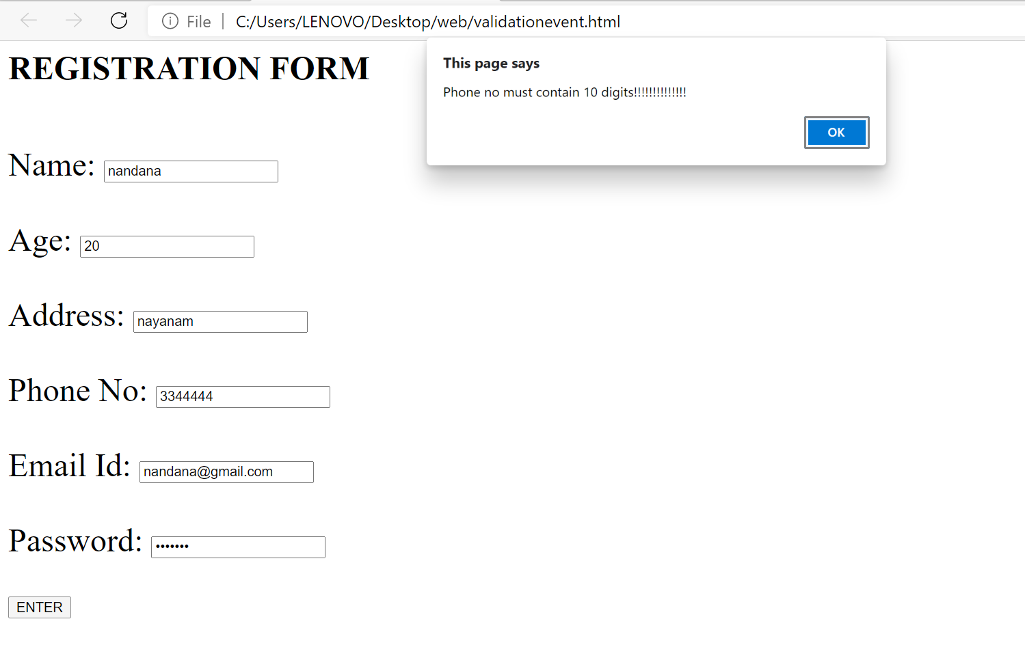

**LAB CYCLE 2 PROGRAM NO:4**

**AIM:** Evaluating JavaScript Event Handling for every click of a button to change the background color of a HTML page

**PROGRAM CODE:**

|  |  |
| --- | --- |
| **CO2-4.html** | <!DOCTYPE HTML>  <html>  <head>  <title>  How to change the background color  after clicking the button ?  </title>  </head>    <body style = "text-align:center;">    <h1 style = "color:green;" >  TKM COLLEGE OF ENGINEERING  </h1>    <p id = "GFG_UP" style =  "font-size: 16px; font-weight: bold;">  </p>    <button onclick = "gfg_Run()">  Click here  </button>    <p id = "GFG_DOWN" style =  "color:green; font-size: 20px; font-weight: bold;">  </p>    <script>  var el_up = document.getElementById("GFG_UP");  var el_down = document.getElementById("GFG_DOWN");  var str = "Click on button to change the background color";    el_up.innerHTML = str;    function changeColor(color) {  document.body.style.background = color;  }    function gfg_Run() {  changeColor('yellow');  el_down.innerHTML = "Background Color changed";  }  </script>  </body>  </html> |

**RESULT:**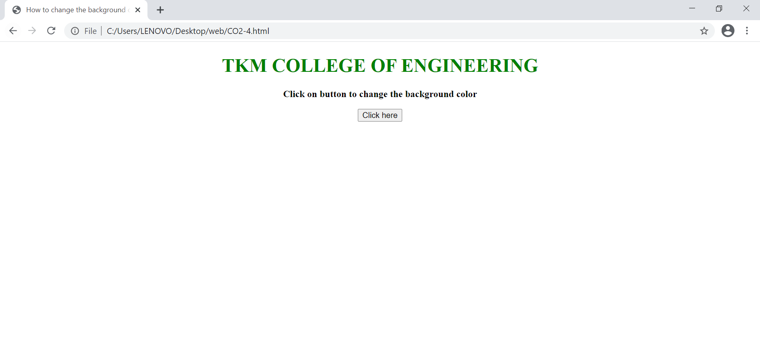

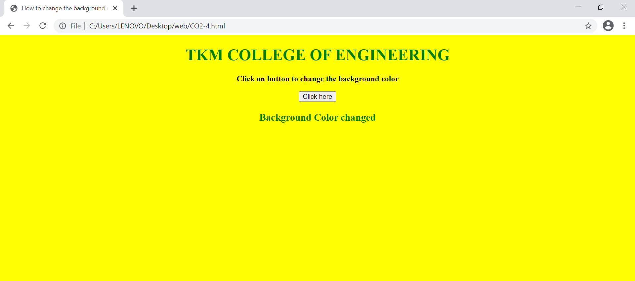

**LAB CYCLE 2 PROGRAM NO:5**

**AIM:** Create a HTML page to display a new image and text when the mouse comes over the existing content in the page using JavaScript Event Handling

**PROGRAM CODE:**

|  |  |
| --- | --- |
| **CO2-5.html** | <html>  <head>  <script language="javascript">  function preload()  {  topon=new Image(100,50);  topon.src="http://tkmce.ac.in/wp-content/themes/tkm/images/tkmce_logo.png";  topoff=new Image(260,280);  topoff.src="http://tkmce.ac.in/wp-content/uploads/2014/09/founder.png";  }  function myMouseOn(n)  {  preload();  imageON=eval(n+"on.src");  document.images[n].src=imageON;  }  function myMouseOff(n)  {  imageOFF=eval(n+"off.src");  document.images[n].src=imageOFF;  }  </script>  </head>  <body >  <h1> Demo for mouse over</h1>  <a href="#" onMouseOut="myMouseOff('top')"; onMouseOver="myMouseOn('top')";>  <img src="Koala.jpg" alt="Show Next" name="top">  </a>  </body>  </html> |

**RESULT:**

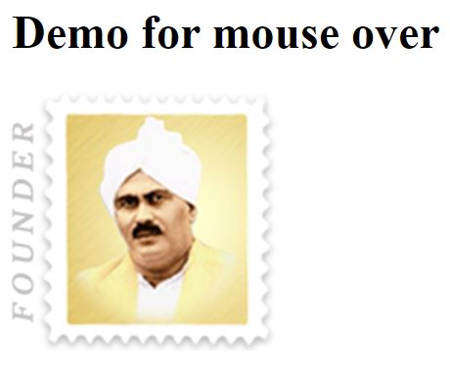

**LAB CYCLE 2 PROGRAM NO: 6**

**AIM:** Create an HTML page to show online exam using JavaScript.

**PROGRAM CODE:**

|  |  |
| --- | --- |
| **CO2-6.html** | <html>  <head>  <title>Exam</title>  <script language="javascript">  function exam(form)  {  var i=0;  if(form.one[2].checked)  i=i+1;  if(form.three[0].checked)  i=i+1;  if(form.four[0].checked)  i=i+1;  if(form.five[1].checked)  i=i+1;  window.alert("Thank You Taking Online Exam! Your Score is: "+i);  }  </script>  </head>  <body bgcolor=silver>  <form onSubmit="exam(this)">  <center><h1><blink>WELCOME TO ONLINE EXAM FORM</blink></h1></center>  <p>  <h1>1)Which is platform independent language</h1>  <input type="radio" name="one" value="c++">  <label>c++</label>  <input type="radio" name="one" value="c">  <label>c</label>  <input type="radio" name="one" value="java">  <label>java</label>  <input type="radio" name="one"value="basic">  <label>BASIC</label>  </p>  <p>  <h1>2) Which is class of all class in java</h1>  <input type="radio" name="three" value="object">  <label>Object</label>  <input type="radio" name="three" value="math">  <label>Math</label>  <input type="radio" name="three" value="system">  <label>System</label>  <input type="radio" name="three" value="graphic">  <label>Graphic</label> </p>  <p>  <h1>3)Frame package is in which package</h1>  <input type="radio" name="four" value="awt">  <label>AWT</label>  <input type="radio" name="four" value="applet">  <label>Applet</label>  <input type="radio" name="four" value="lang">  <label>Lang</label>  <input type="radio" name="four" value="swing">  <label>Swing</label>  </p>  <p>  <h1>4)Java does not support</h1>  <input type="radio" name="five" value="inheritance">  <label>Inheritance</label>  <input type="radio" name="five" value="multiple inheritance">  <label>Multilple inheritance</label>  <input type="radio" name="five" value="polymorphism">  <label>Polymorphism</label>  <input type="radio" name="five" value="encryption">  <label>Encryption</label>  </p>  <p><center>  <input type="submit" value="Submit">  <input type ="reset" value="Reset">  </center></p>  </body>  </html> |

**RESULT:**

